## LAB REPORT

***Submitted by***

# V Allen Jerome [RA2011003011167]

***Under the Guidance of***

# Dr. M. Aruna

#### Faculty Incharge Software Engineering and Project Management , Dept of CSE

***In partial satisfaction of the requirements for the degree of***

# BACHELOR OF TECHNOLOGY

**in**

# COMPUTER SCIENCE ENGINEERING



**SCHOOL OF COMPUTING**

# COLLEGE OF ENGINEERING AND TECHNOLOGY SRM INSTITUTE OF SCIENCE AND TECHNOLOGY KATTANKULATHUR - 603203

## JUNE 2022



SRM INSTITUTION OF SCIENCE AND TECHNOLOGY KATTANKULATHUR-603203

# BONAFIDE CERTIFICATE

Certified that this lab report titled **“ESTATEZ”** is the bonafide work done by V Allen Jerome [RA2011003011167], who carried out the lab exercises under my supervision. Certified further, that to the best of my knowledge the work reported herein does not form part of any other work.

**SIGNATURE**

Ms/Mr/Dr. M. Aruna

#### SEPM – Course Faculty

Faculty Incharge Software Engineering and Project Management Department of C S E

i

**ABSTRACT**

* Our project "ESTATEZ” is related to online application of estate.
* Real estate management system is advanced solution for his/her estate problem. User shows all the properties of Buyer that are secure & verify & send them to the Builder.
* Real System Buy the property &verify them and the online service is provided by us free of charge.
* Here registration is also free of cost. So user can registration by using Real System then Buy the property & verify them. After few hours or days our guys put the estate solution. The software is so reliable to user Our main concept is give best & quick result to user.

**ii**

|  |  |  |
| --- | --- | --- |
|  | **TABLE OF CONTENTS** |  |
| **CHAPTER NO** | **TITLE** | **PAGE NO** |
|  | **ABSTRCT** | ii |
|  | **LIST OF FIGURES** | iv |
| **1** | **PROBLEM STATEMENT** | 2 |
| **2** | **STAKEHOLDERS & PROCESS MODELS** | 3 |
| **3** | **IDENTIFYING REQUIREMENTS** | 4 |
| **4** | **PROJECT PLAN & EFFORT** | 5 |
| **5** | **WORK BREAKDOWN STRUCTURE & RISK ANALYSIS** | 6 |
| **6** | **SYSTEM ARCHITECTURE, USE CASE & CLASS DIAGRAM** | 8 |
| **7** | **ENTITY RELATIONSHIP DIAGRAM** | 10 |
| **8** | **DATA FLOW DIAGRAM** | 11 |
| **9** | **SEQUENCE & COLLABORATION DIAGRAM** | 12 |
| **10** | **DEVELOPMENT OF TESTING FRAMEWORK/USER INTERFACE** | 13 |
| **11** | **TEST CASES & REPORTING** | 14 |
| **12** | **ARCHITECTURE/DESIGN/FRAMEWORK/IMPLE**  **-MENTATION** | 15 |
|  | **CONCLUSION** |  |
|  | **REFERENCES** |  |
|  | **APPENDIX (CODE)** |  |

#### LIST OF FIGURES

|  |  |  |
| --- | --- | --- |
| **FIGURE NO** | **TITLE** | **PAGE NO** |
| **1** | **SYSTEM ARCHITECTURE** | **8** |
| **2** | **USE CASE DIAGRAM** | **8** |
| **3** | **CLASS DIAGRAM** | **9** |
| **4** | **ENTITY RELATIONSHIP DIAGRAM** | **10** |
| **5** | **DATA FLOW DIAGRAM** | **11** |
| **6** | **SEQUENCE & COLLABRATION DIAGRAM** | **12** |

1

# PROBLEM STATEMENT

This website provides a means through which people can avoid property encroachment and register for buying or selling of desired property at the comfort of their homes.

A more secure approach towards property transactions without manipulation of the assets.

# STAKEHOLDERS & PROCESS MODELS

**Stakeholders**

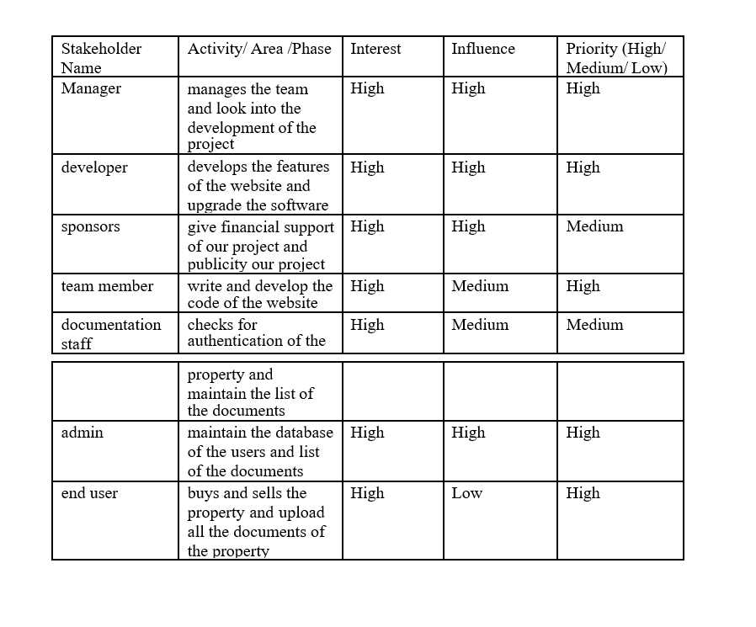

# Agile Methodology:

# *It has a continues interaction with the customer*

# *It allows customer to input the details dynamically*

# *This allows us for continuous upgrade in the software*

# *Developers develop the software according to the client Requirements*

# *Deployment team deploys that particular version*

# *Iteration goes on for the different versions of the project*

# IDENTIFYING REQUIREMENTS

## SOFTWARE REQUIREMENTS:

* **Operating System:** Window XP and above.
* **Browsers:** Chrome or any other latest web page supporting browser.

## HARDWARE REQUIREMENTS:

Here’s what you need to use our med tech website:

* · 20GB HDD.
* · Minimum 256MB RAM.
* · Pentium IV Processor (minimum requirements).
* · Input Devices: Keyboard, Mouse, etc.
* · Output Devices: Monitor, Printer, etc.

# Functional Requirements:

There are a lot of software requirements included in the functional requirements of the Real Estate Listing system, which containing various processes, namely login information and details about user requirements, filtering property according to your needs, buy , rent, sell of all the best real estate .

.

# PROJECT PLAN & EFFORT

# Project Management Plan

|  |  |
| --- | --- |
| **Focus Area** | **Details** |
| Stakeholder | Developers will identify the requirements, Project Manager and Developer team will Analyze the customers are Engaged with the project. |
| Communication Management | Determine communication requirements, roles and responsibilities, tools and techniques. The communication is between the Developer and the end users(buyers/sellers) Customer Requirements are provided by users and the project team will work on it. |
| Authenticity management | Determine the authenticity of the documents and checks for the encroachment if any. |
| Schedule Management | The Project Manager will fix the Milestones of the project Requirement and data collection a week , analyze the data one week, Front end two weeks, Back end two weeks, testing one week.  Schedule Control-The team members will stick to the schedule. |
| Cost Management | Effort of the team members will be estimated.  The Project Manager will assign work to the Team.  The cost of the project is within the Budget. |

**ESTIMATION**

* **Effort and Cost estimation**

|  |  |  |  |  |
| --- | --- | --- | --- | --- |
| **Activity Description** | **Sub-Task** | **Task Description** | **Effort (in hours)** | **Cost in INR** |
| Researching about size, amenity,  Design of the property | finding out the empty properties and connecting between buyers and sellers | Research about the property size, type, developing relations between seller and buyer | 25 | 50,000 |
| Design the website (Front-end). | aligning the text and images and applying scroll effects | Designing the website’s frontend ie designing the UI. | 40 | 24,000 |
| Design the website (Back-end). | design the logic of the website and fixing the loop points | Designing the website’s backend ie. designing and keeping the website updated with the user’s data and all the databases. | 60 | 36,000 |
| Developing the chat between buyer and seller | Developing a chat bot between seller and buyer and the company | Creating a connection between the property owner and buyer and guidance chat bot option | 25 | 15,000 |
| Total |  |  | 175 | 1,05,000 |

|  |  |
| --- | --- |
| **Effort (hr)** | **Cost (INR)** |
| 1 | 600 |

**WORK BREAKDOWN STRUCTURE & RISKANALYSIS**

|  |  |  |
| --- | --- | --- |
| **Name** | **Role** | **Responsibilities** |
| NA | Key Business User (Product Owner) | Provide clear business and user requirements |
| Abhinav D Trivedi | Project Manager | Manage the project |
| Abhinav D Trivedi | Business Analyst | Discuss and Document Requirements |
| Abhinav D Trivedi | Technical Lead | Design the end-to-end architecture |
| V Allen Jerome | UX Designer | Design the user experience |
| V Allen Jerome | Frontend Developer | Develop user interface |
| Abhinav D Trivedi | Backend Developer | Design, Develop and Unit Test Services/API/DB |
| V Allen Jerome | Cloud Architect | Design the cost effective, highly available and scalable architecture |
| V Allen Jerome | Cloud Operations | Provision required Services |
| Jeyanth Prakash | Tester | Define Test Cases and Perform Testing |
| Jeyanth Prakash | Authentication manager | Checks for the authenticity |

**RESPONSIBILITY ASSIGNMENT MATRIX**

|  |  |  |  |  |
| --- | --- | --- | --- | --- |
| **RACI Matrix** | **Team Members** | | | |
| **Activity** | **Name (BA)** | **Name (Developer)** | **Name (Project Manager)** | **Key Business User** |
| User Requirement Documentation | (A) Jeyanth Prakash | (C/I) Abhinav D Trivedi | (I) V Allen Jerome | R |
| Real Estate research and analysis | (R)V Allen Jerome | (C)Jeyanth Prakash | (I)Jeyanth Prakash | C |
| UI/UX design | (R)V Allen Jerome | (C)V Allen Jerome | (I)V Allen Jerome | I |
| database management | (R) Abhinav D Trivedi | (A) Jeyanth Prakash | (I)Abhinav D Trivedi | C |
| Backend development | (R) Abhinav D Trivedi | (A)Abhinav D Trivedi | (I)V Allen Jerome | I |
| Technical Lead | (R)Abhinav D Trivedi | (C)Jeyanth Prakash | (A) Abhinav D Trivedi | C |
| Project Management | (R)Abhinav/Allen | (C)V Allen Jerome | (R)Jeyanth Prakash | C |

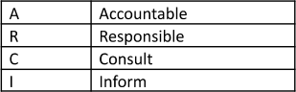RESPONSIBILITY ASSGNMENT MATRIX

#### RISK ANALYSIS – SWOT & RMMM



***Risk Management Framework-Risks and Mitigation***

|  |  |  |
| --- | --- | --- |
| **Response** | **Strategy** | **Examples** |
| **Avoid** | Risk avoidance is a strategy where the project team takes  action to remove the threat of the risk or protect from the impact | * Extending the schedule * Reducing/Removing scope |
| **Transfer** | Risk Transference involves  shifting or transferring the risk threat and impact to a third party. Rather transfer the responsibility and ownership. | * Increase in Complexity of input * change of suppliers to more stable one |
| **Mitigate** | Risk Mitigation is a strategy where the project team takes  action to reduce the probability of the risk occurring. This does not reduce risk or potential impact, but rather reduce the likelihood of it becoming real. | * Increase Testing * Reduce Response time * Reduce process complexity |
| **Accept** | Risk Acceptance means the team acknowledges the risk and its potential impact but decides not to take any preemptive action to prevent it. It is dealt with only if it occurs. | * Inadequate staff size * Inadequate time * Insufficient data * Managing schedule * contingency reserve budget |

# SYSTEM ARCHITECTURE, USE CASE & CLASSDIAGRAM

#### SYSTEM ARCHITECTURE

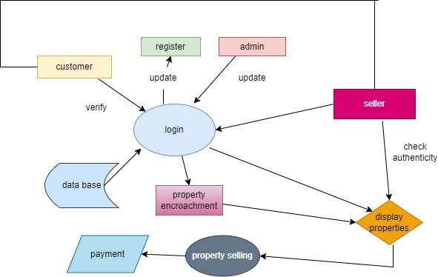

**USE CASE DIAGRAM**

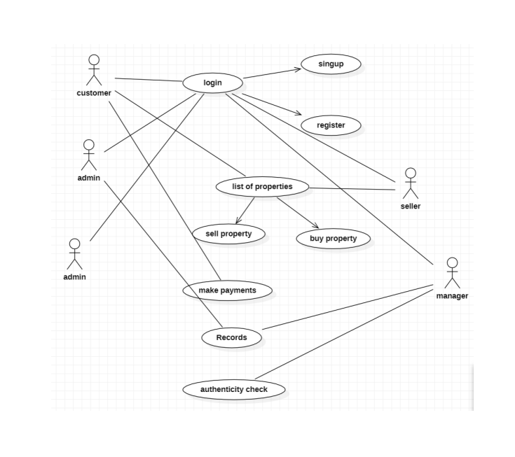

**CLASS DIAGRAM**

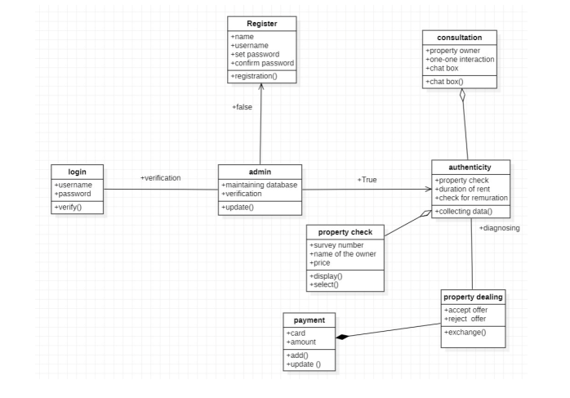

# ENTITY RELATIONSHIP DIAGRAM

ER Diagram of Property listing

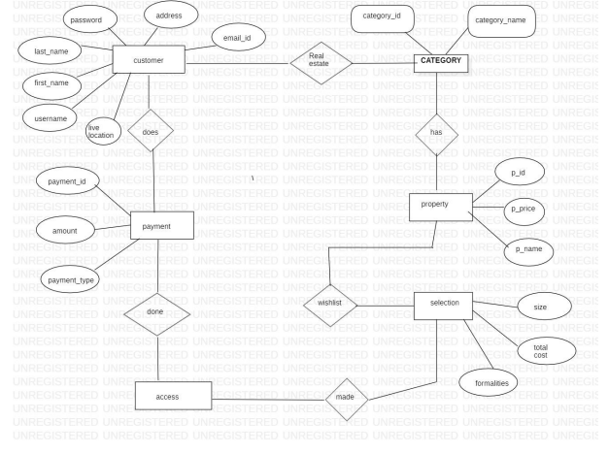

**DATA FLOW DIAGRAM**

**DFD Level 0**

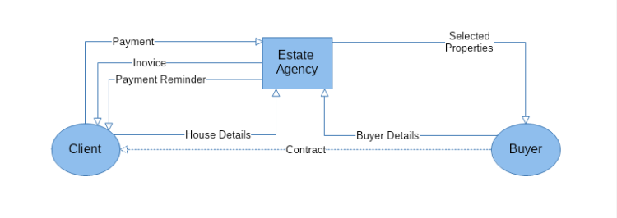

**DFD LEVEL 1**

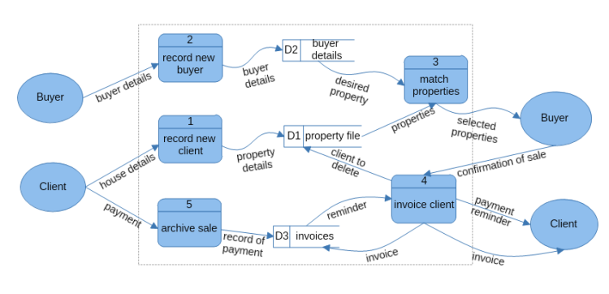

# SEQUENCE DIAGRAM

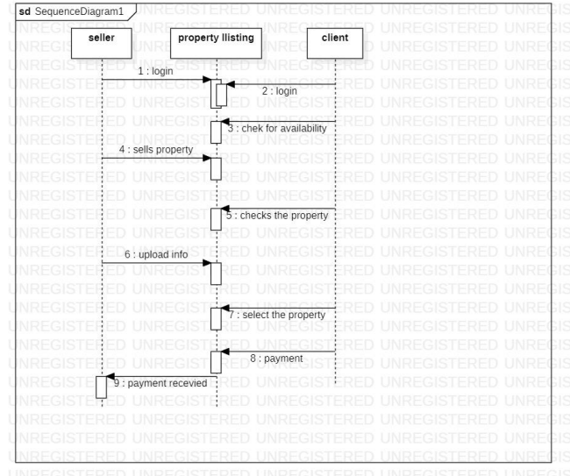

**COLLABORATION DIAGRAM**

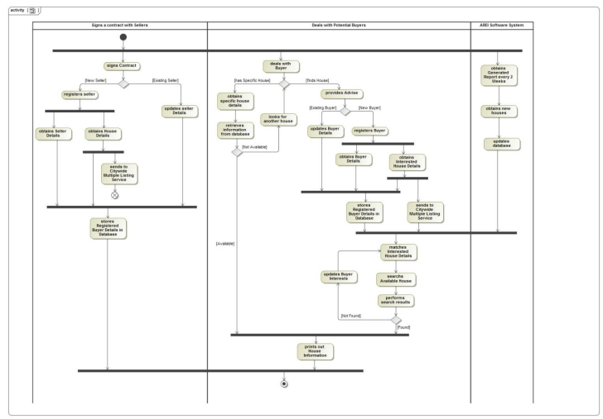

# DEVELOPMENT OF TESTING

### Current Status of the Test report

* Frontend has been Tested Successfully.

### Present obstacles to proceed further

* Both Frontend and Backend has to be linked together.

### Seek help from stakeholders to remove obstacles/constraints

* Programmers/Team Members are working on to connect backend and frontend and finish the project.

|  |  |  |
| --- | --- | --- |
| **Category** | **Progress Against Plan** | **Status** |
| Functional Testing | Green | In-Progress |
| Non-Functional Testing | Green | In-Progress |

|  |  |  |
| --- | --- | --- |
| **Functional** | **Test Case Coverage (%)** | **Status** |
| Login Module | 100% | Completed |
| Admin Module | 90% | In-Progress |
| Student Module | 80% | In-Progress |
| Database (SQL) | 50% | In-Progress |

**CONCLUSION**

* In a technology-driven world, people prefer shortlisting property online and eliminate those properties which are not in accordance with their needs. To save the time and efforts of visiting every property and later selecting the best out of the list, people prefer searching for the property online.
* Property listing website may not be a new business idea but after checking and analyzing the market trend, it has a secure and promising future. Those who are planning to start a property listing website, there is a huge scope. Entrepreneurs need to keep in mind the latest technology and tactics involved in building a formidable real estate listing website.

# REFERENCES

1. SEPM Lab Experiments (1-12)

2. 9304-ArticleText-16272-1-10-20200523.pdf

# APPENDIX (CODE)

<html lang="en-US"><head>

<meta charset="UTF-8">

<meta name="viewport" content="width=device-width, initial-scale=1">

<link rel="profile" href="https://gmpg.org/xfn/11">

<title>ESTATEZ – Your dream come true</title>

<meta name="robots" content="max-image-preview:large">

<link rel="dns-prefetch" href="//fonts.googleapis.com">

<link rel="dns-prefetch" href="//s.w.org">

<link rel="alternate" type="application/rss+xml" title="ESTATEZ » Feed" href="http://localhost/abhinav/feed/">

<link rel="alternate" type="application/rss+xml" title="ESTATEZ » Comments Feed" href="http://localhost/abhinav/comments/feed/">

<script>

window._wpemojiSettings = {"baseUrl":"https:\/\/s.w.org\/images\/core\/emoji\/14.0.0\/72x72\/","ext":".png","svgUrl":"https:\/\/s.w.org\/images\/core\/emoji\/14.0.0\/svg\/","svgExt":".svg","source":{"concatemoji":"http:\/\/localhost\/abhinav\/wp-includes\/js\/wp-emoji-release.min.js?ver=6.0"}};

/*! This file is auto-generated */

!function(e,a,t){var n,r,o,i=a.createElement("canvas"),p=i.getContext&&i.getContext("2d");function s(e,t){var a=String.fromCharCode,e=(p.clearRect(0,0,i.width,i.height),p.fillText(a.apply(this,e),0,0),i.toDataURL());return p.clearRect(0,0,i.width,i.height),p.fillText(a.apply(this,t),0,0),e===i.toDataURL()}function c(e){var t=a.createElement("script");t.src=e,t.defer=t.type="text/javascript",a.getElementsByTagName("head")[0].appendChild(t)}for(o=Array("flag","emoji"),t.supports={everything:!0,everythingExceptFlag:!0},r=0;r<o.length;r++)t.supports[o[r]]=function(e){if(!p||!p.fillText)return!1;switch(p.textBaseline="top",p.font="600 32px Arial",e){case"flag":return s([127987,65039,8205,9895,65039],[127987,65039,8203,9895,65039])?!1:!s([55356,56826,55356,56819],[55356,56826,8203,55356,56819])&&!s([55356,57332,56128,56423,56128,56418,56128,56421,56128,56430,56128,56423,56128,56447],[55356,57332,8203,56128,56423,8203,56128,56418,8203,56128,56421,8203,56128,56430,8203,56128,56423,8203,56128,56447]);case"emoji":return!s([129777,127995,8205,129778,127999],[129777,127995,8203,129778,127999])}return!1}(o[r]),t.supports.everything=t.supports.everything&&t.supports[o[r]],"flag"!==o[r]&&(t.supports.everythingExceptFlag=t.supports.everythingExceptFlag&&t.supports[o[r]]);t.supports.everythingExceptFlag=t.supports.everythingExceptFlag&&!t.supports.flag,t.DOMReady=!1,t.readyCallback=function(){t.DOMReady=!0},t.supports.everything||(n=function(){t.readyCallback()},a.addEventListener?(a.addEventListener("DOMContentLoaded",n,!1),e.addEventListener("load",n,!1)):(e.attachEvent("onload",n),a.attachEvent("onreadystatechange",function(){"complete"===a.readyState&&t.readyCallback()})),(e=t.source||{}).concatemoji?c(e.concatemoji):e.wpemoji&&e.twemoji&&(c(e.twemoji),c(e.wpemoji)))}(window,document,window._wpemojiSettings);

</script><script src="http://localhost/abhinav/wp-includes/js/wp-emoji-release.min.js?ver=6.0" type="text/javascript" defer=""></script>

<style>

img.wp-smiley,

img.emoji {

display: inline !important;

border: none !important;

box-shadow: none !important;

height: 1em !important;

width: 1em !important;

margin: 0 0.07em !important;

vertical-align: -0.1em !important;

background: none !important;

padding: 0 !important;

}

</style>

<link rel="stylesheet" id="astra-theme-css-css" href="http://localhost/abhinav/wp-

d="4fd6861" data-element_type="widget" data-widget_type="heading.default">

<div class="elementor-widget-container">

<h6 class="elementor-heading-title elementor-size-default">Who We Are</h6> </div>

</div>

<div class="elementor-element elementor-element-8f80252 elementor-widget elementor-widget-heading" data-id="8f80252" data-element_type="widget" data-widget_type="heading.default">

<div class="elementor-widget-container">

<h2 class="elementor-heading-title elementor-size-default">About Us</h2> </div>

</div>

<div class="elementor-element elementor-element-97d1cc6 elementor-widget-divider--view-line elementor-widget elementor-widget-divider" data-id="97d1cc6" data-element_type="widget" data-widget_type="divider.default">

<div class="elementor-widget-container">

<div class="elementor-divider">

<span class="elementor-divider-separator">

</span>

</div>

</div>

</div>

<div class="elementor-element elementor-element-c628318 elementor-widget elementor-widget-heading" data-id="c628318" data-element_type="widget" data-widget_type="heading.default">

<div class="elementor-widget-container">

<h5 class="elementor-heading-title elementor-size-default">We are the real estate agents</h5> </div>

</div>

<div class="elementor-element elementor-element-6ea6eb0 elementor-widget elementor-widget-text-editor" data-id="6ea6eb0" data-element_type="widget" data-widget_type="text-editor.default">

<div class="elementor-widget-container">

<p>We provide the best and cheapest home and apartments, just one look and you are set to to purchase.</p> </div>

</div>

<div class="elementor-element elementor-element-065a851 elementor-widget elementor-widget-button" data-id="065a851" data-element_type="widget" data-widget_type="button.default">

<div class="elementor-widget-container">

<div class="elementor-button-wrapper">

<a href="#" class="elementor-button-link elementor-button elementor-size-lg" role="button">

<span class="elementor-button-content-wrapper">

<span class="elementor-button-text">Read More</span>

</span>

</a>

</div>

</div>

</div>

</div>

</div>

<div class="elementor-column elementor-col-50 elementor-top-column elementor-element elementor-element-c93b51a" data-id="c93b51a" data-element_type="column" data-settings="{&quot;background_background&quot;:&quot;classic&quot;}">

<div class="elementor-widget-wrap elementor-element-populated">

<div class="elementor-element elementor-element-8560ea5 elementor-widget elementor-widget-spacer" data-id="8560ea5" data-element_type="widget" data-widget_type="spacer.default">

<div class="elementor-widget-container">

<style>/*! elementor - v3.6.6 - 08-06-2022 */

.e-container.e-container--row .elementor-spacer-inner{width:var(--spacer-size)}.e-container.e-container--column .elementor-spacer-inner,.elementor-column .elementor-spacer-inner{height:var(--spacer-size)}</style> <div class="elementor-spacer">

<div class="elementor-spacer-inner"></div>

</div>

</div>

</div>

</div>

</div>

</div>

</section>

<section class="elementor-section elementor-top-section elementor-element elementor-element-c771978 elementor-section-content-top elementor-section-boxed elementor-section-height-default elementor-section-height-default" data-id="c771978" data-element_type="section" data-settings="{&quot;background_background&quot;:&quot;classic&quot;}">

<div class="elementor-container elementor-column-gap-no">

<div class="elementor-column elementor-col-100 elementor-top-column elementor-element elementor-element-f5ab6ed" data-id="f5ab6ed" data-element_type="column">

<div class="elementor-widget-wrap elementor-element-populated">

<div class="elementor-element elementor-element-5dbaf0d elementor-widget elementor-widget-heading" data-id="5dbaf0d" data-element_type="widget" data-widget_type="heading.default">

<div class="elementor-widget-container">

<h6 class="elementor-heading-title elementor-size-default">Find Your Perfect Home</h6> </div>

</div>

<div class="elementor-element elementor-element-01bf2f5 elementor-widget elementor-widget-heading" data-id="01bf2f5" data-element_type="widget" data-widget_type="heading.default">

<div class="elementor-widget-container">

<h2 class="elementor-heading-title elementor-size-default">Unique Listings</h2> </div>

</div>

<div class="elementor-element elementor-element-46fa423 elementor-widget-divider--view-line elementor-widget elementor-widget-divider" data-id="46fa423" data-element_type="widget" data-widget_type="divider.default">

<div class="elementor-widget-container">

<div class="elementor-divider">

<span class="elementor-divider-separator">

</span>

</div>

</div>

</div>

<section class="elementor-section elementor-inner-section elementor-element elementor-element-c554e50 elementor-section-content-top elementor-section-boxed elementor-section-height-default elementor-section-height-default" data-id="c554e50" data-element_type="section">

<div class="elementor-container elementor-column-gap-no">

<div class="elementor-column elementor-col-33 elementor-inner-column elementor-element elementor-element-72eb57e" data-id="72eb57e" data-element_type="column">

<div class="elementor-widget-wrap elementor-element-populated">

<div class="elementor-element elementor-element-95de904 elementor-widget elementor-widget-image" data-id="95de904" data-element_type="widget" data-widget_type="image.default">

<div class="elementor-widget-container">

<a href="#">

<img width="390" height="260" src="http://localhost/abhinav/wp-content/uploads/2019/04/img-06-free-img.jpg" class="attachment-full size-full" alt="Property Photo" loading="lazy"> </a>

</div>

</div>

<div class="elementor-element elementor-element-dd0bd83 elementor-widget elementor-widget-heading" data-id="dd0bd83" data-element_type="widget" data-widget_type="heading.default">

<div class="elementor-widget-container">

<h6 class="elementor-heading-title elementor-size-default">For Rent</h6> </div>

</div>

<div class="elementor-element elementor-element-252549e elementor-align-left elementor-icon-list--layout-traditional elementor-list-item-link-full_width elementor-widget elementor-widget-icon-list" data-id="252549e" data-element_type="widget" data-widget_type="icon-list.default">

<div class="elementor-widget-container">

<ul class="elementor-icon-list-items">

<li class="elementor-icon-list-item">

<span class="elementor-icon-list-icon">

<i aria-hidden="true" class="fas fa-building"></i> </span>

<span class="elementor-icon-list-text">Commercial</span>

</li>

</ul>

</div>

</div>

<div class="elementor-element elementor-element-f926683 elementor-widget elementor-widget-heading" data-id="f926683" data-element_type="widget" data-widget_type="heading.default">

<div class="elementor-widget-container">

<h3 class="elementor-heading-title elementor-size-default"><a href="#">Awesome Office Space</a></h3> </div>

</div>

<div class="elementor-element elementor-element-133a31a elementor-widget elementor-widget-heading" data-id="133a31a" data-element_type="widget" data-widget_type="heading.default">

<div class="elementor-widget-container">

<h5 class="elementor-heading-title elementor-size-default">$ 5235/mo</h5> </div>

</div>

<div class="elementor-element elementor-element-aa8e04f elementor-widget elementor-widget-heading" data-id="aa8e04f" data-element_type="widget" data-widget_type="heading.default">

<div class="elementor-widget-container">

<h6 class="elementor-heading-title elementor-size-default">123 Fifth Avenue, NY 10160</h6> </div>

</div>

<div class="elementor-element elementor-element-ac5539f elementor-widget elementor-widget-text-editor" data-id="ac5539f" data-element_type="widget" data-widget_type="text-editor.default">

<div class="elementor-widget-container">

<p>Offices: 20 / Baths: 6 / Sq Ft: 10450&nbsp;</p> </div>

</div>

<div class="elementor-element elementor-element-47ac6ca elementor-widget elementor-widget-button" data-id="47ac6ca" data-element_type="widget" data-widget_type="button.default">

<div class="elementor-widget-container">

<div class="elementor-button-wrapper">

<a href="#" class="elementor-button-link elementor-button elementor-size-sm" role="button">

<span class="elementor-button-content-wrapper">

<span class="elementor-button-text">Details</span>

</span>

</a>

</div>

</div>

</div>

</div>

</div>

<div class="elementor-column elementor-col-33 elementor-inner-column elementor-element elementor-element-9c4eb7f" data-id="9c4eb7f" data-element_type="column">

<div class="elementor-widget-wrap elementor-element-populated">

<div class="elementor-element elementor-element-820d884 elementor-widget elementor-widget-image" data-id="820d884" data-element_type="widget" data-widget_type="image.default">

<div class="elementor-widget-container">

<a href="#">

<img width="390" height="260" src="http://localhost/abhinav/wp-content/uploads/2019/04/img-07-free-img.jpg" class="attachment-full size-full" alt="Property Photo" loading="lazy"> </a>

</div>

</div>

<div class="elementor-element elementor-element-487d7aa elementor-widget elementor-widget-heading" data-id="487d7aa" data-element_type="widget" data-widget_type="heading.default">

<div class="elementor-widget-container">

<h6 class="elementor-heading-title elementor-size-default">For Rent</h6> </div>

</div>

<div class="elementor-element elementor-element-592b652 elementor-align-left elementor-icon-list--layout-traditional elementor-list-item-link-full_width elementor-widget elementor-widget-icon-list" data-id="592b652" data-element_type="widget" data-widget_type="icon-list.default">

<div class="elementor-widget-container">

<ul class="elementor-icon-list-items">

<li class="elementor-icon-list-item">

<span class="elementor-icon-list-icon">

<i aria-hidden="true" class="fas fa-building"></i> </span>

<span class="elementor-icon-list-text">Commercial</span>

</li>

</ul>

</div>

</div>

<div class="elementor-element elementor-element-51ae4e8 elementor-widget elementor-widget-heading" data-id="51ae4e8" data-element_type="widget" data-widget_type="heading.default">

<div class="elementor-widget-container">

<h3 class="elementor-heading-title elementor-size-default"><a href="#">Modern Apartment</a></h3> </div>

</div>

<div class="elementor-element elementor-element-84b4311 elementor-widget elementor-widget-heading" data-id="84b4311" data-element_type="widget" data-widget_type="heading.default">

<div class="elementor-widget-container">

<h5 class="elementor-heading-title elementor-size-default">$ 1100/mo</h5> </div>

</div>

<div class="elementor-element elementor-element-4734592 elementor-widget elementor-widget-heading" data-id="4734592" data-element_type="widget" data-widget_type="heading.default">

<div class="elementor-widget-container">

<h6 class="elementor-heading-title elementor-size-default">123 Fifth Avenue, NY 10160</h6> </div>

</div>

<div class="elementor-element elementor-element-65ceab4 elementor-widget elementor-widget-text-editor" data-id="65ceab4" data-element_type="widget" data-widget_type="text-editor.default">

<div class="elementor-

<div class="elementor-element elementor-element-2eb396b elementor-widget elementor-widget-heading" data-id="2eb396b" data-element_type="widget" data-widget_type="heading.default">

<div class="elementor-widget-container">

<h2 class="elementor-heading-title elementor-size-default">Let's Find You Together The Place You Deserve</h2> </div>

</div>

<div class="elementor-element elementor-element-e9154d9 elementor-widget-divider--view-line elementor-widget elementor-widget-divider" data-id="e9154d9" data-element_type="widget" data-widget_type="divider.default">

<div class="elementor-widget-container">

<div class="elementor-divider">

<span class="elementor-divider-separator">

</span>

</div>

</div>

</div>

<div class="elementor-element elementor-element-1713008 elementor-widget elementor-widget-text-editor" data-id="1713008" data-element_type="widget" data-widget_type="text-editor.default">

<div class="elementor-widget-container">

<p>Contact us for any query and to find you dream home.</p> </div>

</div>

<div class="elementor-element elementor-element-9695c19 elementor-align-center elementor-widget elementor-widget-button" data-id="9695c19" data-element_type="widget" data-widget_type="button.default">

<div class="elementor-widget-container">

<div class="elementor-button-wrapper">

<a href="#" class="elementor-button-link elementor-button elementor-size-lg" role="button">

<span class="elementor-button-content-wrapper">

<span class="elementor-button-text">Contact Us</span>

</span>

</a>

</div>

</div>

</div>

</div>

</div>

</div>

</section>

</div>

</div><!-- .entry-content .clear -->

</article><!-- #post-## -->

</main><!-- #main -->

</div><!-- #primary -->

</div> <!-- ast-container -->

</div><!-- #content -->

<footer class="site-footer" id="colophon" itemtype="https://schema.org/WPFooter" itemscope="itemscope" itemid="#colophon">

<div class="site-below-footer-wrap ast-builder-grid-row-container site-footer-focus-item ast-builder-grid-row-2-equal ast-builder-grid-row-tablet-2-equal ast-builder-grid-row-mobile-full ast-footer-row-stack ast-footer-row-tablet-stack ast-footer-row-mobile-stack" data-section="section-below-footer-builder">

<div class="ast-builder-grid-row-container-inner">

<div class="ast-builder-footer-grid-columns site-below-footer-inner-wrap ast-builder-grid-row">

<div class="site-footer-below-section-1 site-footer-section site-footer-section-1">

<div class="ast-builder-layout-element ast-flex site-footer-focus-item ast-footer-copyright" data-section="section-footer-builder">

<div class="ast-footer-copyright"><p>Copyright © 2022 ESTATEZ</p>

</div> </div>

</div>

<div class="site-footer-below-section-2 site-footer-section site-footer-section-2">

<div class="footer-widget-area widget-area site-footer-focus-item ast-footer-html-1" data-section="section-fb-html-1">

<div class="ast-header-html inner-link-style-"><div class="ast-builder-html-element"><p>Powered by ESTATEZ</p>

</div></div> </div>

</div>

</div>

</div>

</div>

</footer><!-- #colophon -->

</div><!-- #page -->

<script id="astra-theme-js-js-extra">

var astra = {"break_point":"921","isRtl":""};

</script>

<script src="http://localhost/abhinav/wp-content/themes/astra/assets/js/minified/frontend.min.js?ver=3.8.2" id="astra-theme-js-js"></script>

<script src="http://localhost/abhinav/wp-content/plugins/elementor/assets/js/webpack.runtime.min.js?ver=3.6.6" id="elementor-webpack-runtime-js"></script>

<script src="http://localhost/abhinav/wp-includes/js/jquery/jquery.min.js?ver=3.6.0" id="jquery-core-js"></script>

<script src="http://localhost/abhinav/wp-includes/js/jquery/jquery-migrate.min.js?ver=3.3.2" id="jquery-migrate-js"></script>

<script src="http://localhost/abhinav/wp-content/plugins/elementor/assets/js/frontend-modules.min.js?ver=3.6.6" id="elementor-frontend-modules-js"></script>

<script src="http://localhost/abhinav/wp-content/plugins/elementor/assets/lib/waypoints/waypoints.min.js?ver=4.0.2" id="elementor-waypoints-js"></script>

<script src="http://localhost/abhinav/wp-includes/js/jquery/ui/core.min.js?ver=1.13.1" id="jquery-ui-core-js"></script>

<script id="elementor-frontend-js-before">

var elementorFrontendConfig = {"environmentMode":{"edit":false,"wpPreview":false,"isScriptDebug":false},"i18n":{"shareOnFacebook":"Share on Facebook","shareOnTwitter":"Share on Twitter","pinIt":"Pin it","download":"Download","downloadImage":"Download image","fullscreen":"Fullscreen","zoom":"Zoom","share":"Share","playVideo":"Play Video","previous":"Previous","next":"Next","close":"Close"},"is_rtl":false,"breakpoints":{"xs":0,"sm":480,"md":768,"lg":1025,"xl":1440,"xxl":1600},"responsive":{"breakpoints":{"mobile":{"label":"Mobile","value":767,"default_value":767,"direction":"max","is_enabled":true},"mobile_extra":{"label":"Mobile Extra","value":880,"default_value":880,"direction":"max","is_enabled":false},"tablet":{"label":"Tablet","value":1024,"default_value":1024,"direction":"max","is_enabled":true},"tablet_extra":{"label":"Tablet Extra","value":1200,"default_value":1200,"direction":"max","is_enabled":false},"laptop":{"label":"Laptop","value":1366,"default_value":1366,"direction":"max","is_enabled":false},"widescreen":{"label":"Widescreen","value":2400,"default_value":2400,"direction":"min","is_enabled":false}}},"version":"3.6.6","is_static":false,"experimentalFeatures":{"e_dom_optimization":true,"e_optimized_assets_loading":true,"e_optimized_css_loading":true,"a11y_improvements":true,"e_import_export":true,"additional_custom_breakpoints":true,"e_hidden_wordpress_widgets":true,"landing-pages":true,"elements-color-picker":true,"favorite-widgets":true,"admin-top-bar":true},"urls":{"assets":"http:\/\/localhost\/abhinav\/wp-content\/plugins\/elementor\/assets\/"},"settings":{"page":[],"editorPreferences":[]},"kit":{"global_image_lightbox":"yes","active_breakpoints":["viewport_mobile","viewport_tablet"],"lightbox_enable_counter":"yes","lightbox_enable_fullscreen":"yes","lightbox_enable_zoom":"yes","lightbox_enable_share":"yes","lightbox_title_src":"title","lightbox_description_src":"description"},"post":{"id":432,"title":"ESTATEZ%20%E2%80%93%20Your%20dream%20come%20true","excerpt":"","featuredImage":false}};

</script>

<script src="http://localhost/abhinav/wp-content/plugins/elementor/assets/js/frontend.min.js?ver=3.6.6" id="elementor-frontend-js"></script><span id="elementor-device-mode" class="elementor-screen-only"></span>

<script src="http://localhost/abhinav/wp-includes/js/underscore.min.js?ver=1.13.3" id="underscore-js"></script>

<script id="wp-util-js-extra">

var _wpUtilSettings = {"ajax":{"url":"\/abhinav\/wp-admin\/admin-ajax.php"}};

</script>

<script src="http://localhost/abhinav/wp-includes/js/wp-util.min.js?ver=6.0" id="wp-util-js"></script>

<script id="wpforms-elementor-js-extra">

var wpformsElementorVars = {"captcha_provider":"recaptcha","recaptcha_type":"v2"};

</script>

<script src="http://localhost/abhinav/wp-content/plugins/wpforms-lite/assets/js/integrations/elementor/frontend.min.js?ver=1.7.4.2" id="wpforms-elementor-js"></script>

<script src="http://localhost/abhinav/wp-content/plugins/wpforms-lite/assets/js/jquery.validate.min.js?ver=1.19.3" id="wpforms-validation-js"></script>

<script src="http://localhost/abhinav/wp-content/plugins/wpforms-lite/assets/js/mailcheck.min.js?ver=1.1.2" id="wpforms-mailcheck-js"></script>

<script src="http://localhost/abhinav/wp-content/plugins/wpforms-lite/assets/js/punycode.min.js?ver=1.0.0" id="wpforms-punycode-js"></script>

<script src="http://localhost/abhinav/wp-content/plugins/wpforms-lite/assets/js/wpforms.min.js?ver=1.7.4.2" id="wpforms-js"></script>

<script>

/(trident|msie)/i.test(navigator.userAgent)&&document.getElementById&&window.addEventListener&&window.addEventListener("hashchange",function(){var t,e=location.hash.substring(1);/^[A-z0-9_-]+$/.test(e)&&(t=document.getElementById(e))&&(/^(?:a|select|input|button|textarea)$/i.test(t.tagName)||(t.tabIndex=-1),t.focus())},!1);

</script>

<script type="text/javascript">

/* <![CDATA[ */

var wpforms_settings = {"val_required":"This field is required.","val_email":"Please enter a valid email address.","val_email_suggestion":"Did you mean {suggestion}?","val_email_suggestion_title":"Click to accept this suggestion.","val_email_restricted":"This email address is not allowed.","val_number":"Please enter a valid number.","val_number_positive":"Please enter a valid positive number.","val_confirm":"Field values do not match.","val_checklimit":"You have exceeded the number of allowed selections: {#}.","val_limit_characters":"{count} of {limit} max characters.","val_limit_words":"{count} of {limit} max words.","val_recaptcha_fail_msg":"Google reCAPTCHA verification failed, please try again later.","val_empty_blanks":"Please fill out all blanks.","uuid_cookie":"","locale":"en","wpforms_plugin_url":"http:\/\/localhost\/abhinav\/wp-content\/plugins\/wpforms-lite\/","gdpr":"","ajaxurl":"http:\/\/localhost\/abhinav\/wp-admin\/admin-ajax.php","mailcheck_enabled":"1","mailcheck_domains":[],"mailcheck_toplevel_domains":["dev"],"is_ssl":""}

/* ]]> */

</script>

<script src="http://localhost/abhinav/wp-content/plugins/elementor/assets/lib/swiper/swiper.min.js?ver=5.3.6"></script></body></html>